Assessment Tool 3
CO3_AT2_Case Study

Course: Computer Vision Name: Karanam Meghana
Course Code: ITA0506 Register No: 192321126
1. Harris Corner Detection for Satellite Image Registration
1. Introduction / Case Understanding
Remote sensing systems capture satellite images of the same geographical region at different times to monitor environmental changes such as deforestation, floods, urban development, crop changes, and land-use changes. Before comparing these images, they must be accurately aligned using image registration.
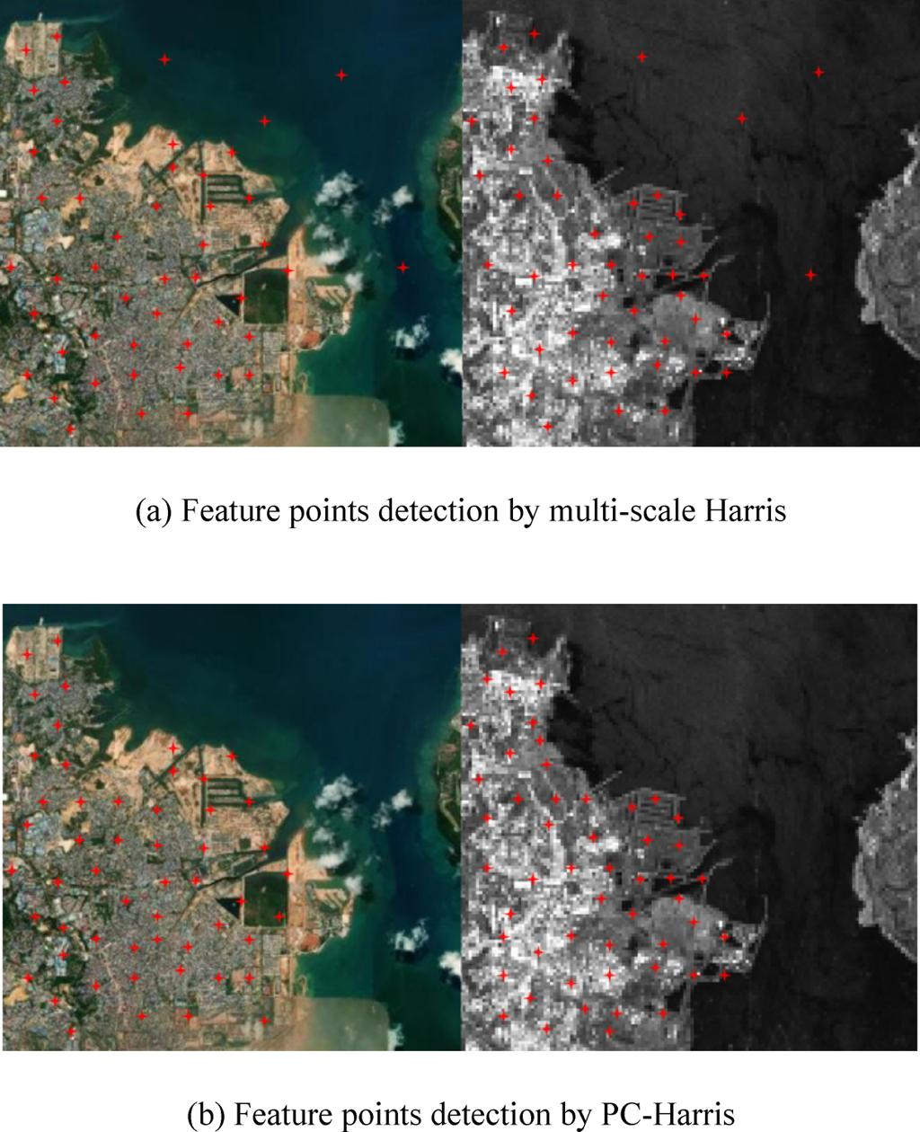
In this case, the system initially uses edge detection to identify matching regions. However, changes in illumination, image orientation, shadows, and background details make edge-based matching unreliable. Therefore, Harris Corner Detection is introduced to identify stable and distinctive feature points for accurate image registration.
2. Problem Identification
The main problem is inaccurate alignment of satellite images captured under different imaging conditions.
The important issues are:
- Different illumination and sunlight conditions.
- Changes in shadows.
- Different image orientations or viewing angles.
- Seasonal changes in vegetation and terrain.
- Similar edges appearing at multiple locations.
- Difficulty in identifying exact corresponding points.
If incorrect features are matched, the final registered image will be misaligned, which can lead to incorrect environmental change detection.
3. Limitations of Existing Method
The existing method uses edge detection, but it has several limitations.
a) Edges are not distinctive
An edge represents a boundary rather than a specific point. Long roads, buildings, rivers, and field boundaries can produce long edges, making exact matching difficult.
b) Poor localization
An edge can contain many pixels with similar properties. Therefore, it is difficult to determine the exact corresponding position between two images.
c) Sensitive to illumination
Different sunlight conditions can change pixel intensities and cause some edges to appear stronger or weaker.
d) Shadow interference
Shadows from buildings, trees, and mountains may create additional edges or shift existing boundaries.
e) Background changes
Vegetation, clouds, terrain, and other environmental conditions can change between image acquisitions.
f) Matching ambiguity
Two different geographical regions may contain similar edges, causing the system to select an incorrect correspondence.
Therefore, edge detection alone is not sufficiently reliable for precise satellite image registration.
4. Relevant Concept
The proposed method is Harris Corner Detection.
A corner is a point where image intensity changes significantly in two directions. For example:
- Building corners
- Road intersections
- Bridge corners
- Field intersections
- Structural junctions
Harris detects these points using the second-moment matrix .
The Harris response is:
where:
- = structure/second-moment matrix
- = empirical constant, generally around 0.04–0.06
- = determinant of
- = trace of
A large positive value of indicates a strong corner
5. Technical Analysis
Harris Corner Detection analyzes how much the intensity changes when a small image window is shifted.
- Flat region: little change in any direction.
- Edge: large change mainly in one direction.
- Corner: large change in two directions.
Therefore, corners provide much stronger positional information than ordinary edges.
For satellite image registration, Harris can identify corresponding structural points in both images.
For example:
Image 1 → Building Corner A
Image 2 → Same Building Corner A
These corresponding points can be matched to determine how one image must be transformed to align with the other.
Harris therefore improves:
Feature localization
Corners provide precise 2D locations.
Matching accuracy
Corners are more distinctive than long edges.
Registration reliability
Multiple matched corners can be used to estimate geometric transformations.
Robustness
Harris performs better than simple edge matching under moderate changes in illumination and image conditions, although basic Harris is not fully invariant to large scale or rotation changes 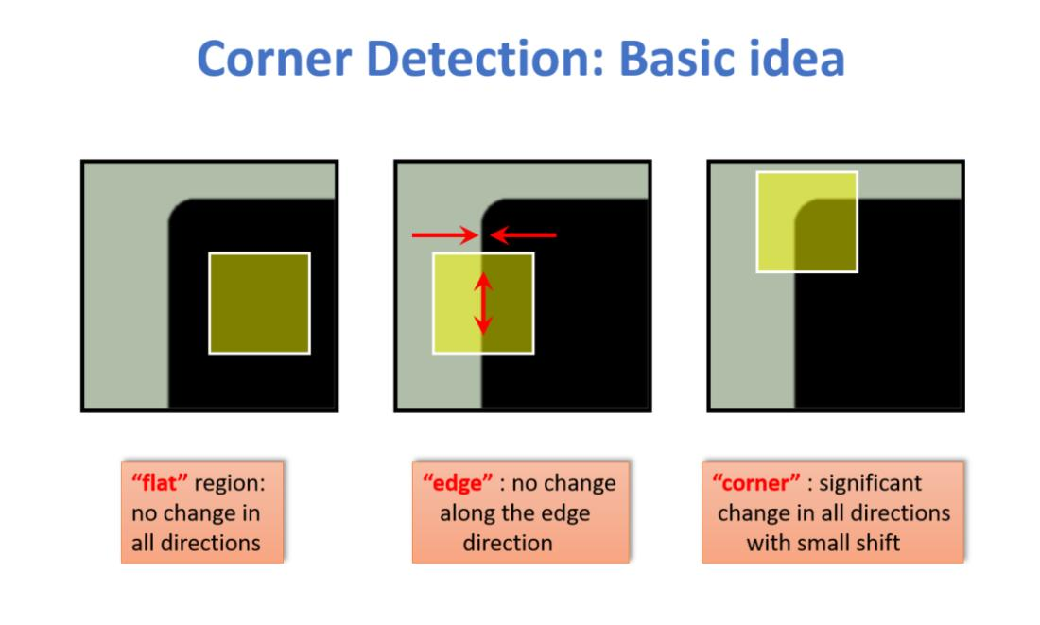
6. Comparison
Feature | Edge Detection | Harris Corner Detection
Feature type | Boundary/line | Point
Localization | Low–moderate | High
Distinctiveness | Low–moderate | High
Matching accuracy | Lower | Higher
Illumination sensitivity | High | Better under moderate changes
Background interference | High | Lower
Exact point identification | Difficult | Easy
Registration suitability | Limited | Highly suitable
Thus, Harris is more suitable when the objective is to find stable corresponding points.
7. Proposed Solution / Processing Pipeline
The improved image registration system can use the following process:
Satellite Image 1
↓
Preprocessing
↓
Harris Corner Detection
↓
Feature Point Extraction
Satellite Image 2
↓
Preprocessing
↓
Harris Corner Detection
↓
Feature Point Extraction
Then:
Feature Matching
↓
Remove Incorrect Matches
↓
Estimate Geometric Transformation
↓
Image Alignment / Registration
↓
Environmental Change Detection
Possible transformations include:
- Translation
- Rotation
- Scaling
- Affine transformation
- Perspective transformation
8. Justification
Harris Corner Detection is preferred because it provides distinctive and accurately localized feature points.
Compared with edges:
- Corners have better positional accuracy.
- They provide stronger matching information.
- They reduce ambiguity during correspondence.
- They improve transformation estimation.
- They provide more reliable registration results.
Therefore, replacing edge detection with Harris Corner Detection is a feasible and technically justified solution for satellite image registration
9. Conclusion
Edge detection has limitations in satellite image registration because edges are non-unique, difficult to localize, and sensitive to illumination, shadows, orientation, and background changes.
Harris Corner Detection identifies distinctive points where intensity changes in two directions. These points can be accurately localized and matched between images, allowing reliable estimation of geometric transformations.
Therefore, the Harris-based approach provides better feature localization, improved matching accuracy, and greater robustness, making it more suitable for accurate satellite image registration and environmental monitoring.

2. Image Representation for Real-Time Object Detection
1. Introduction / Case Understanding
An autonomous surveillance system continuously captures high-resolution color images to detect vehicles and pedestrians in real time.
Processing RGB images directly requires more computational power and memory because every pixel contains three color channels. This can slow down edge detection and feature extraction. 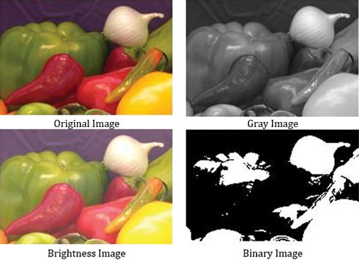
Therefore, the system considers converting RGB images into grayscale or binary representations to improve processing speed while maintaining sufficient detection accuracy.
2. Problem Identification
The main problem is the high computational complexity of processing high-resolution color images in real time.
The system must achieve two objectives:
- High processing speed
- Accurate vehicle and pedestrian detection
Simply reducing the amount of image information may improve speed but can also reduce detection accuracy.
Therefore, the challenge is to select an image representation that provides the best balance between efficiency and accuracy.
3. Limitations of Existing Method
The existing system directly processes RGB images.
a) High computational cost
RGB images contain three channels:
- Red
- Green
- Blue
Therefore, more data must be processed.
b) Higher memory requirement
Three channels require more storage compared with grayscale.
c) Slower feature extraction
Feature detection algorithms must process more information, increasing execution time.
d) Reduced real-time performance
For high-resolution images captured continuously, processing RGB images may introduce delays.
Therefore, directly using RGB is not always suitable for applications requiring fast respons
4. Relevant Concept
Three main image representations are considered:
Color/RGB
Contains three channels:
Grayscale
Contains one intensity channel.
A common conversion is:
Binary
Contains only two possible values:
Binary images are generally obtained using thresholding:
where is the threshold. 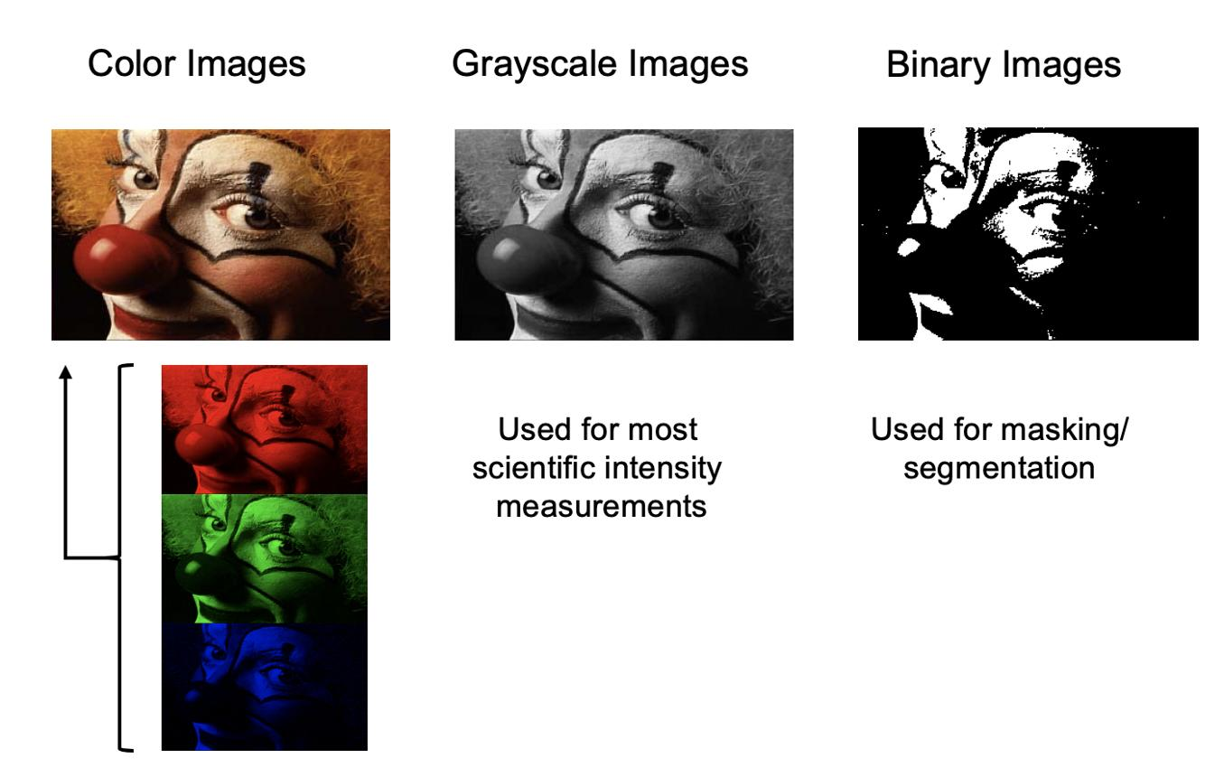
5. Technical Analysis
A. RGB Representation
RGB preserves maximum visual information.
Advantages:
- Preserves color.
- Useful when color helps identify objects.
- Provides rich information.
Disadvantages:
- High computational cost.
- High memory requirement.
- Slower feature extraction.
Therefore, RGB provides high information but lower computational efficiency.
B. Grayscale Representation
Grayscale converts three channels into one intensity channel.
Advantages:
- Reduces computational complexity.
- Reduces memory usage.
- Faster edge detection.
- Preserves object shape and boundaries.
- Suitable for Sobel, Prewitt, and Canny edge detection.
- Provides useful information for feature extraction.
Disadvantage:
- Color information is lost.
However, for many vehicle and pedestrian detection tasks, shape, edges, intensity, and structure are more important than color.
C. Binary Representation
Binary representation uses only two values.
Advantages:
- Very low computational cost.
- Very low memory requirement.
- Fast processing.
- Useful for foreground/background segmentation.
Disadvantages:
- Significant information loss.
- Sensitive to threshold selection.
- Shadows may be incorrectly detected.
- Fine textures disappear.
- Object boundaries may be distorted.
- Poor performance in complex backgrounds.
Therefore, binary representation is not ideal as the primary representation for general object detection.
6. Comparison
Parameter | RGB | Grayscale | Binary
Channels | 3 | 1 | 1-bit representation
Computational cost | High | Low | Very low
Memory | High | Low | Very low
Color information | Preserved | Lost | Lost
Edge detection | Good but costly | Very good | Variable
Feature extraction | Rich | Good | Limited
Information loss | Low | Moderate | High
Threshold sensitivity | Low | Low | High
Real-time suitability | Moderate | Excellent | Conditional
From the comparison, grayscale provides the best balance.
7. Proposed Solution / Processing Pipeline
The recommended processing pipeline is:
High-Resolution RGB Image
↓
Grayscale Conversion
↓
Noise Reduction / Filtering
↓
Edge Detection / Feature Detection
↓
Feature Extraction
↓
Vehicle & Pedestrian Detection
If segmentation is required, binary processing can be applied later:
Grayscale Image
↓
Thresholding
↓
Binary Mask
↓
Object Segmentation
Thus, binary representation should be used as an additional processing stage when appropriate, rather than replacing grayscale completely. 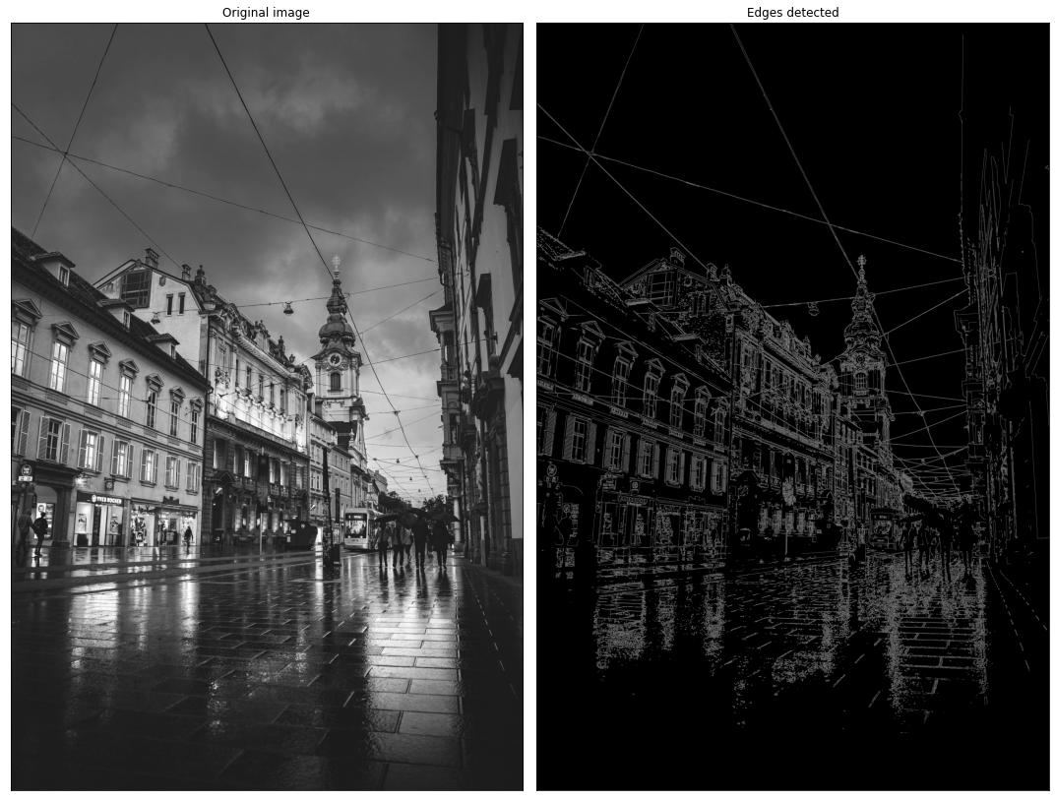
8. Justification
Grayscale is the most appropriate general-purpose representation for this real-time surveillance application.
The reasons are:
- It reduces the data from three channels to one.
- It decreases computational complexity.
- It reduces memory requirements.
- It provides fast edge detection.
- It preserves important object shapes and boundaries.
- It supports effective feature extraction.
- It provides better accuracy than directly using binary images in complex scenes.
RGB should be retained when color is essential for distinguishing objects, while binary representation can be used for specific segmentation tasks.
Therefore, grayscale provides the best speed–accuracy trade-off.
9. Conclusion
RGB images contain complete color information but require higher computational resources. Binary images are extremely fast but lose significant information and are sensitive to threshold selection.
Grayscale provides the most suitable balance between computational efficiency and object detection accuracy. It reduces processing requirements while preserving important features such as edges, shapes, corners, and intensity patterns.
Therefore, the recommended approach is:
Binary representation can be used later for suitable segmentation tasks.
Hence, grayscale is the preferred representation for accurate, reliable, and real-time vehicle and pedestrian detection.

